CSCE 606 - Vaccine Hesitancy Game: Iteration 3

**Team roles:**

* Scrum Master: Catherine Shen
* Product Owner: Benjamin Hawn
* Team Member: Liuyi Jin
* Team Member: Bhogesh Maddirala

**Github repo:** <https://github.com/bhawn/CSCE_606_Project>

**Pivotal Tracker:** <https://www.pivotaltracker.com/n/projects/2536278>

**Deployment:** <https://powerful-sierra-98545.herokuapp.com>

**Customer Meeting Dates:**

* (12/01/21) Sent an updated video demo of current progress to Dr. Walker for him to share with VetMed faculty.

**User Stories :**

* **Completed with Low-fi UI**:
  + Feature: Create Drop entities

As a Player

I want to encounter drops (vaccines, spike proteins)

So I can improve my attacks.

| **Design** | **Implemented** |
| --- | --- |
|  |  |

* + Feature: Increase amount of ammo player can shoot on vaccine drop pickup

As a Player

I want more ammo

So that I can keep using the same weapon

| **Design** | **Implemented** |
| --- | --- |
|  | Same weapon = more ammo |

* + Feature: Entity Collision (pick up drop, damage, etc)

As a Player

I want to interact with other entities

So that I can interact with different parts of the game.

| **Design** | **Implemented** |
| --- | --- |
|  |  |

* + Feature: Enemy Spawn Progression

As a Player

I want harder and more enemies as I progress

So that I can feel accomplished if I win.

| **Design** | **Implemented** |
| --- | --- |
|  |  |

* + Feature: Score

As a Player

I want to see a game score

So I can see how well I'm doing and compare with friends.

| **Design** | **Implemented** |
| --- | --- |
|  |  |

* + Feature: Weapon Variety

As a Player

I want there to be multiple weapons

So that there is variety in the game

| **Design** | **Implemented** |
| --- | --- |
|  |  |

* **Current** User Stories with low-fi UI:
  + Feature: Create player HP mechanic

As Player

I want an HP mechanic

So that I can see how close I am to failing

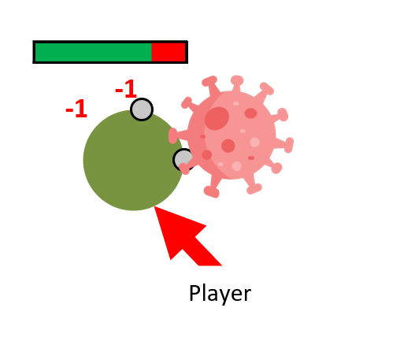

* + Feature: Death and/or Respawn

As a Player

I want there to be a consequence in failing

So that I can feel accomplished in winning

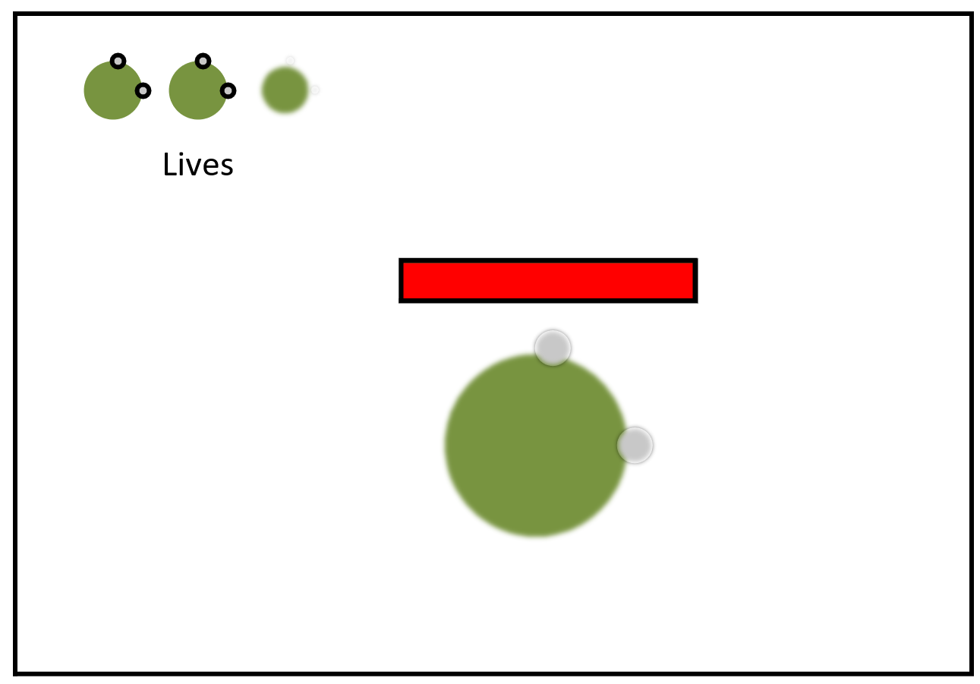

* + Feature: Game and Phaser framework documentation

As a developer

I want to document how the game works

So that in the future, developers can improve the game

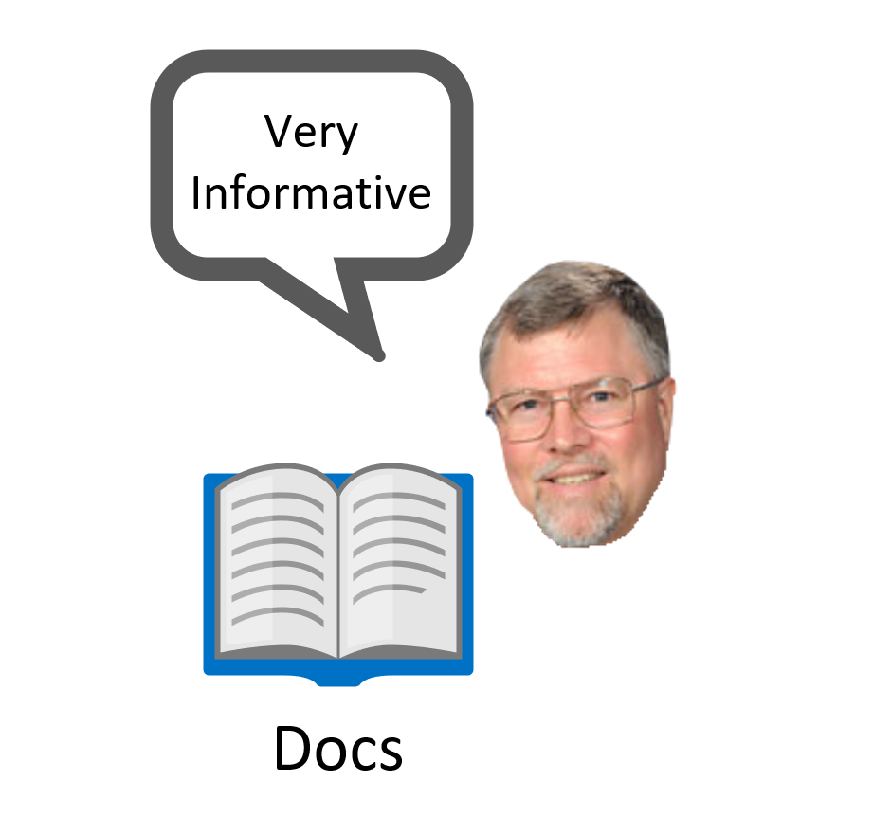

* + Feature: (Low Priority) Loading/Credits Screen

As a developer

I want there to be a loading/credits screen

So that I can load assets or let people know that I worked on this.

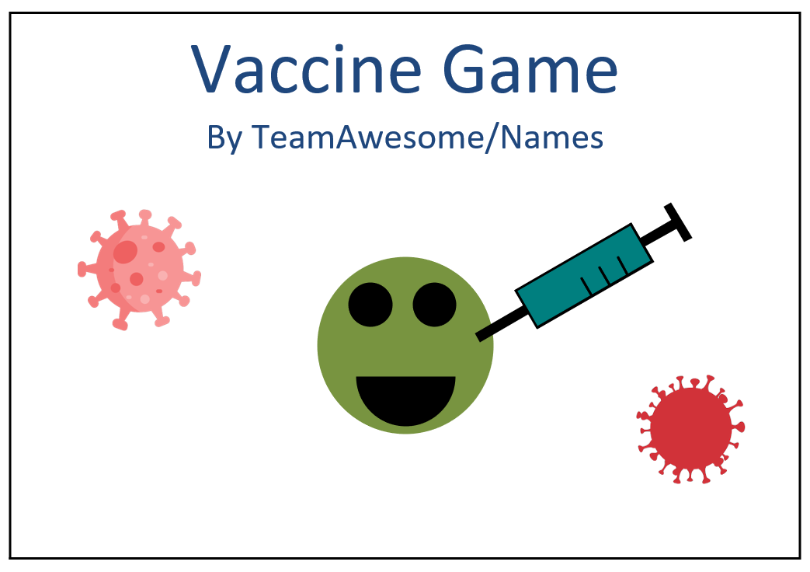

* + Feature: (Low Priority) Main Menu Screen

As a Player

I want a Main Menu Screen

So that I can play the game when I choose

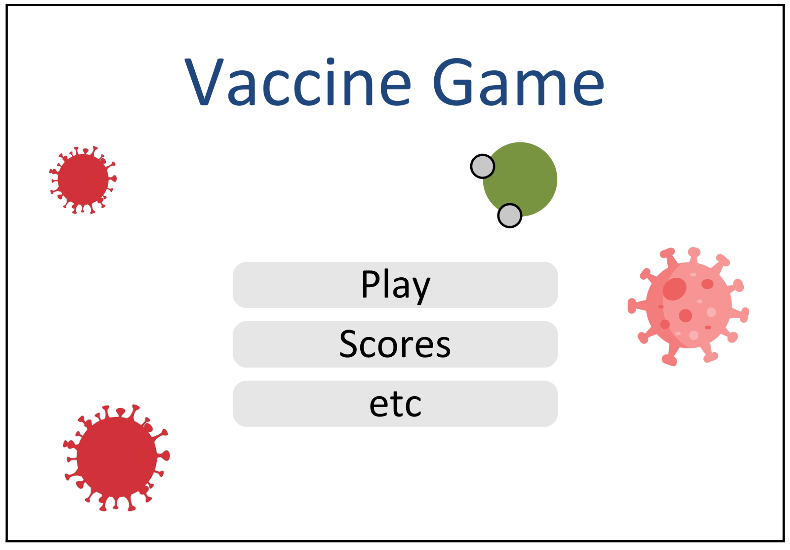

* + Feature: (Low Priority) In Game Instructions (e.g. WASD to move/Defeat the viruses!)

As a Player

I need instructions

So I know how and why to play.

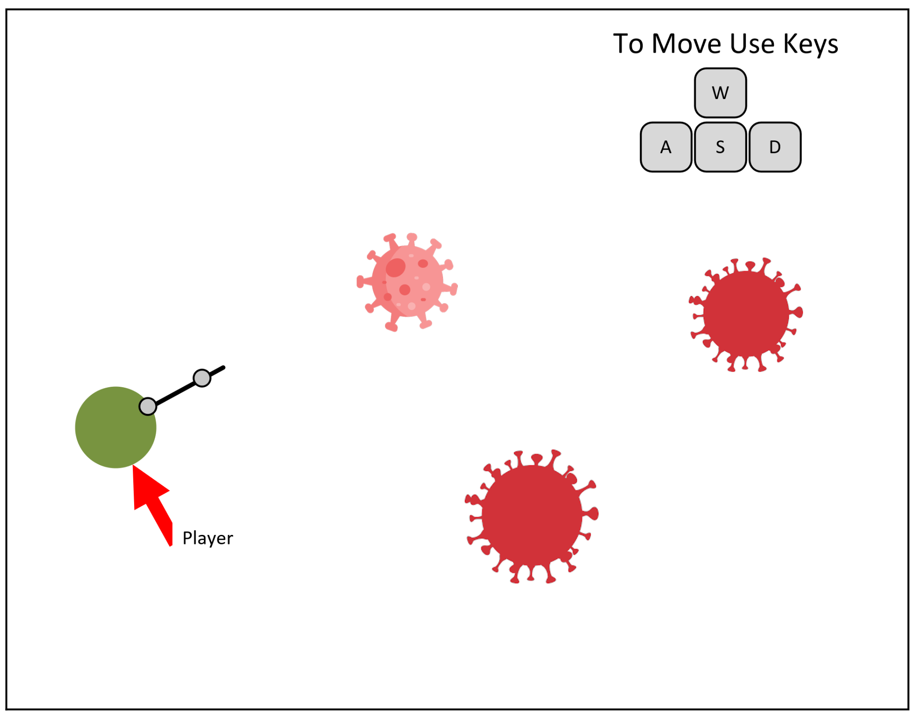

* + Feature: (Low Priority) Browser compatibility

As a user of a old phone model

I want the game to work

So I can play it

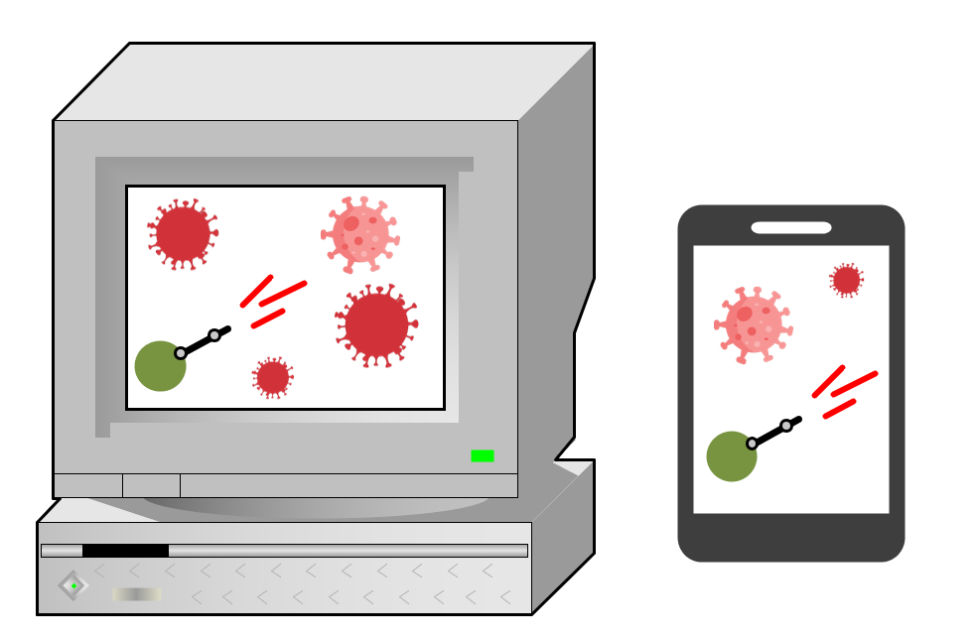

* + Feature: (Low Priority) Shader Effects (Lights, particles on bullet hit, etc..)

As a player

I want the game to have ƒancy effects

So that the game looks nice

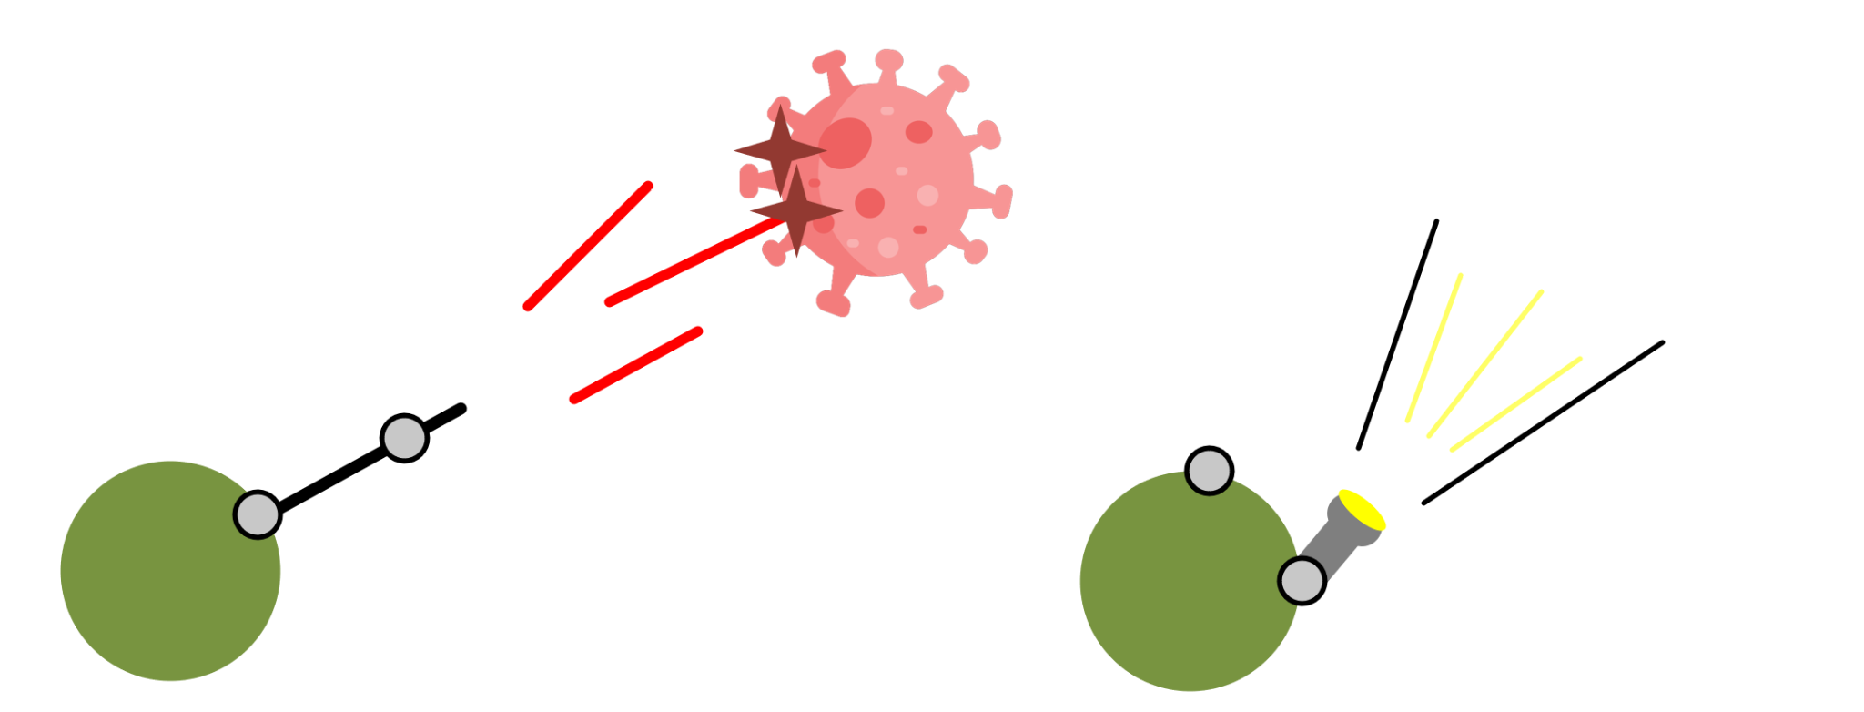

* + Feature: Preparation for production site (getting sent code sent over & setup)

As a player

I want to be able to find the game online

So that I can play the game

* + Feature: Temporary Asset Replacement

As a developer

I want textures that match the theme and are free use

So the game is themed and the assets can be used.

**Design Diagram:**

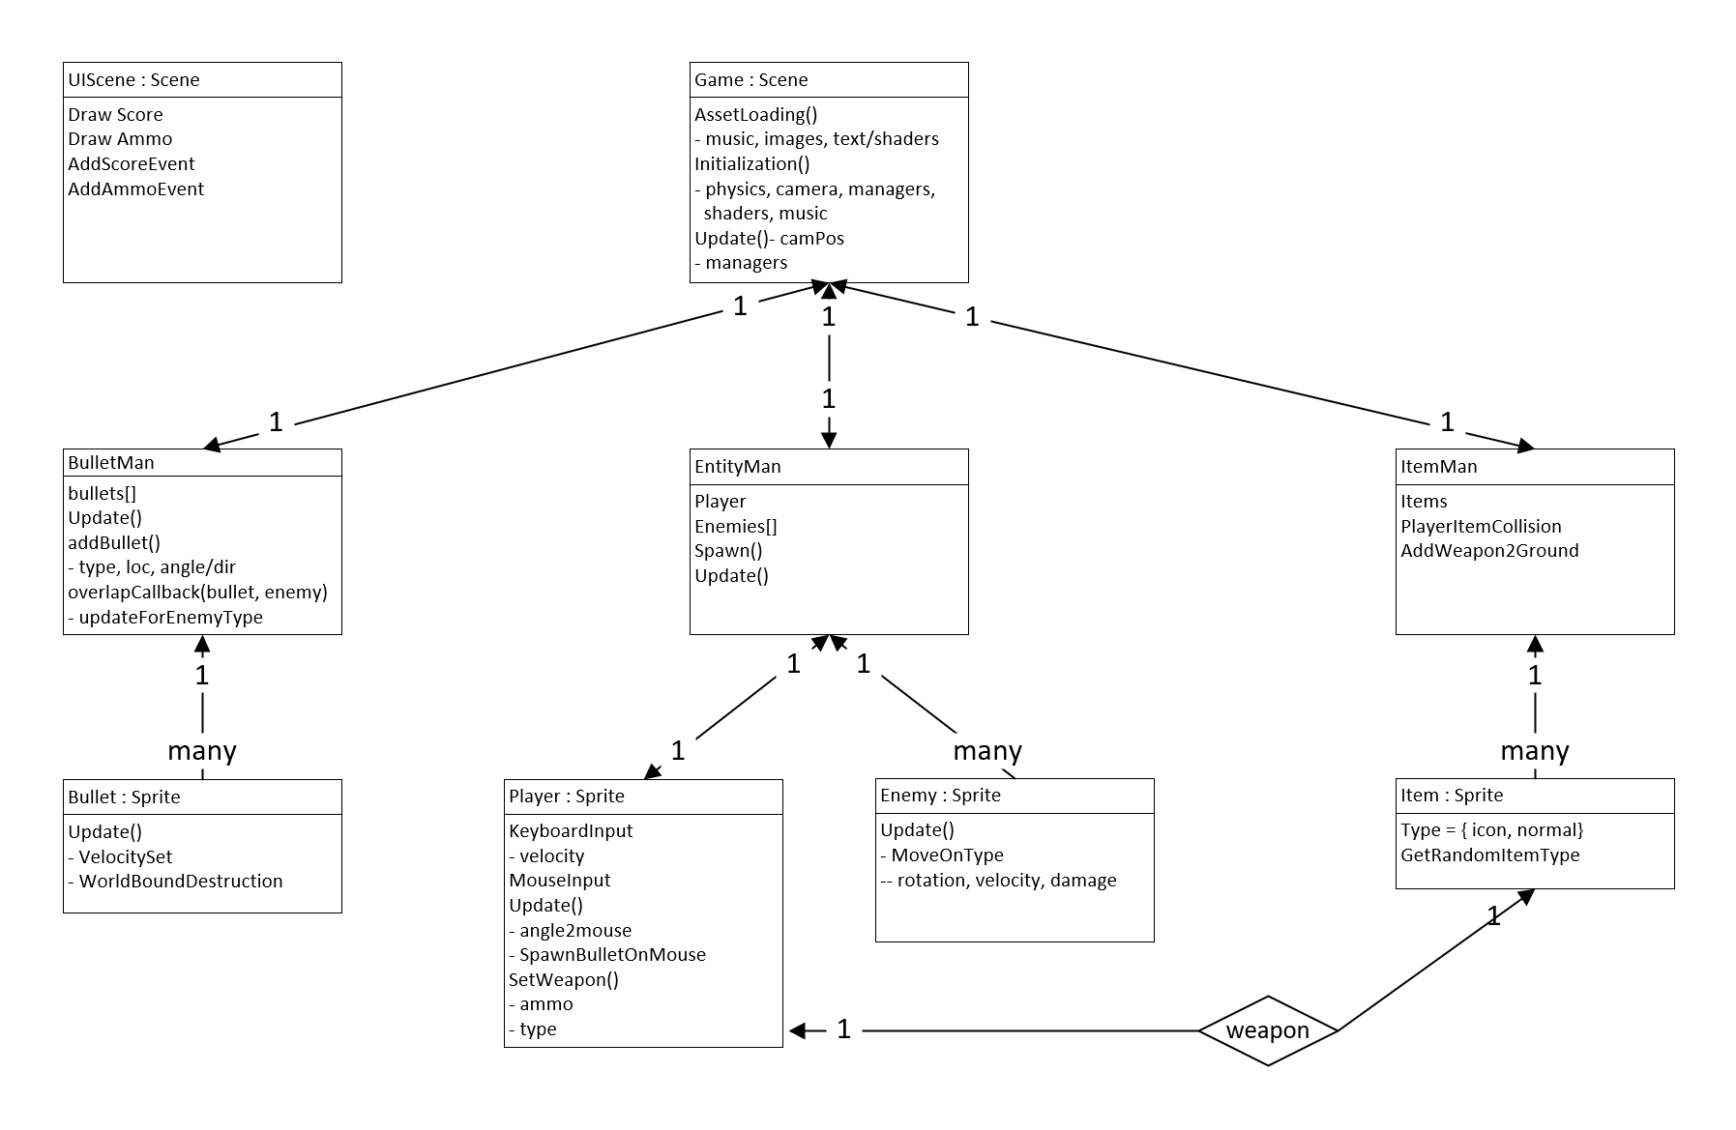

**StoryBoard:**

**Incomplete User Stories:**

If you were not able to implement all the stories that you initially chose for this iteration, please list which ones and why not.

* Time constraints such as heavy class workloads limited the amount of stories to implement. The user stories from last iteration that were not able to be implemented this iteration were death and/or respawn, game and Phaser framework documentation, and the low priority stories:
  + loading/credits screen
  + Main menu screen
  + In-game instructions
  + Browser compatibility
  + Shader effects
* The uncompleted user stories are now in our current iteration of user stories to implement.

**Reason For Changed Stories:**

* No user stories were changed this iteration but two new stories were added--find free-to-use textures that match the theme of a vaccine game and have the game ready to be deployed to make it playable to the public.

**Code Tests & Evaluations:**

We started testing our vaccine hesitancy game this iteration and it has been a challenging process. We are using mocha and chai frameworks to test our javascript game that runs on Phaser 3.0. The game rules, logic, implementation and requirements keep changing since we are still not in the final phase of our development, and our customer is giving us new input. Had we tested the main logic of the game we would have to rewrite 100’s of times, therefore I only tested a few functions that are important to our game and they won’t change in design. As well as that we created a separate html file to view how our tests are passing and their time duration, since we will have so many tests and printing to the console won’t be a great way to look through each individual one. Our main goal in terms of testing for this iteration was to understand how it works in javascript and choosing the right framework to use for that, and we managed to achieve that and do a good amount of testing, which we will build on. By early next week, we would have added a lot more tests that use the functions integral to our game and also finish up working on code coverage as well. I pasted a copy of some of our tests that we did, along with how it looks when they pass.

